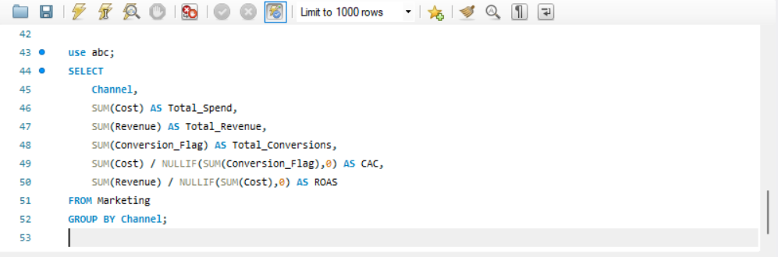
It shows the total spend, revenue, conversions, Customer Acquisition Cost (CAC), and Return on Ad Spend (ROAS) By Individual Channel.

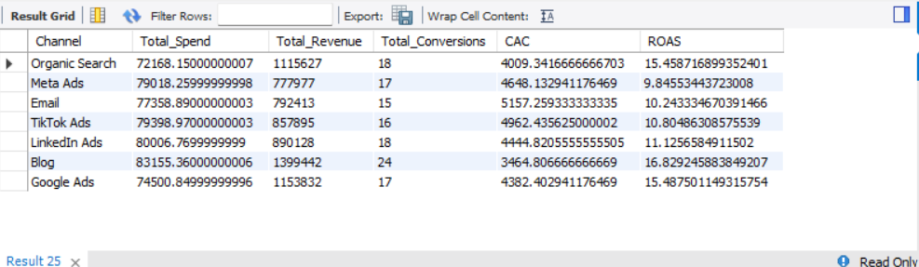
QUERY-;

SOLUTION-;

